PITCH HIT & RUN
Loaner Bag Equipment
1 x SKLZ QUICKSTER SPORT NET
24 x EASTON SOFTCORE BASEBALLS
2 x TEES
2 x REPLACEMENT TEE TOPS
1 x BLUE STOPWATCH
1 x HOME PLATE (PLEASE USE MARKERS IF NOT PROVIDED)
2 X BASES (PLEASE USE MARKERS IF NOT PROVIDED)
1 x 24INCH BAT
1 x 26INCH BAT
1 x 29INCH BAT

Please provide:
80m Tape Measure (Or best Available)
Note Pad
Pens
Markers (FOR THROWING & RUNNING IF NOT PROVIDED)

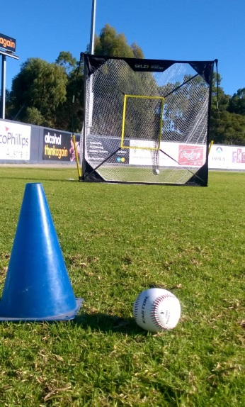
SET UP
PITCH:
- TARGET 30 feet away from throwing markers
- 5 Baseballs
- Each Pitcher, 5 throws, score X/5 each attempt in hitting the center “Strike” Zone of the net.
HIT: Option 1: 1 Tee Option 2:
2 Tees

- Extend measuring tape out from Tee/Tees. (If Further than your measuring tape, estimate the distance.)
3 ATTEMPTS: Have each batter hit the ball as far as they can along the Measuring tape.
Record the distance of the ball once it has stopped rolling.
Only record the furthest hit of each attempt.
RUN: Set up Bases/Markers 80 feet (25m) Apart. Then another on a 90˚ angle 80 feet (25m) away.
- The base runner will be timed from when they start till when they finish (touch the last base).
Start
80feet
80feet
Finish
Group Sheet
Print x3 so one rotates with each group
# | Name | Pitch (out of 5) | Hit (Furthest hit) | Run 1 | Run 2
1
2
3
4
5
6
7
8
9
10
11
12
13
14
15
16
17
18
19
20
21
22
23
24
25
26
27
28
29
30

