SOME SIMPLIFIED MACHINE PITCH/TBALL RULES FOR TEACHERS
- 10 - 12 players per team
(Class of 20 -24 Students split in half)
- Only 10 fielders may take the field (Infield + 4 outfielders)
- Every player takes a turn to bat regardless of the number of outs.
- If the batter reaches a count of 3 Strikes or 4 Balls, the batter will be given a side toss ball to hit into play.
- Base runners cannot leave the base until the ball has been hit
- If batters/runner run on a fly ball and it is caught they must go back and touch the base they just ran from, before they may proceed to the next base.
- Advance 1 base on an overthrow
- If the batter is hit by a pitch – walk a base
- Fielders must not obstruct runners but runners must not stop fielders from fielding a ball
- No need to tag on a forced play
- Runner must touch all bases
- Must bat in order as per score sheet
- Must not deviate more than 1 metre from line to avoid being tagged
- Pitcher must stand next to the pitching machine (If applicable)
- Must tag runner with ball in hand.
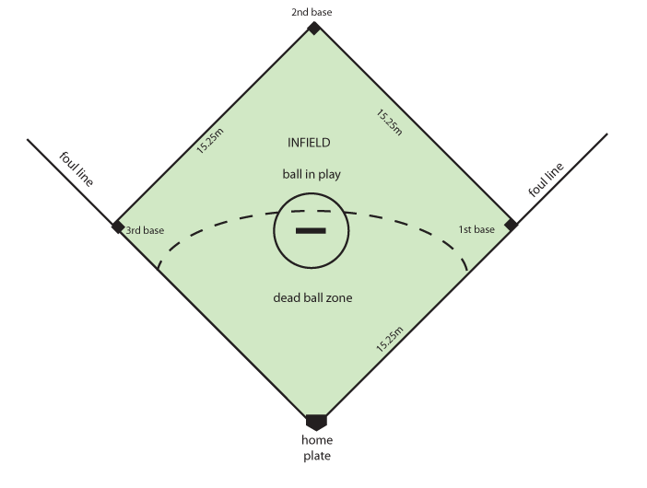
Equipment
- 1 Home Plate
- 3 Bases
- 1 Tee/Pitching Machine
- Tballs/Baseballs

