Name____________________________________ Homeroom____________

Label the critical elements of the Overhand Throw:
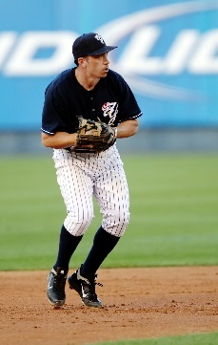
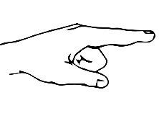

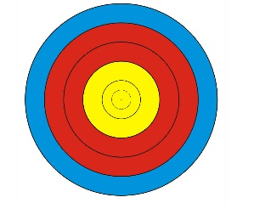

______________________ _____________________ ______________________
______________________ _____________________ ______________________

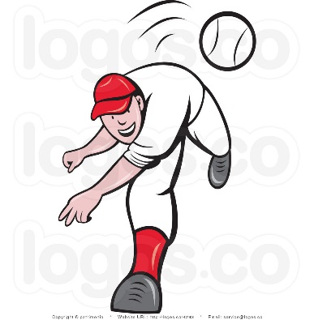

______________________ ______________________
______________________ ______________________

- Ball back by ear

- Side facing target

- Twist body/Follow Through
- Step with opposite
Foot

- Point to Target

