Dual Fungo Infield Routine. Ideal for LL, Juniors & Seniors
- The Dual Fungo (2 Coaches hitting) is an effective drill for working on fielding and throwing mechanics.
- Players around the diamond receive a high amount of repetitions in a shorter timeframe
- Other coaches are able to keep an eye on fielding, feetwork and throwing actions.

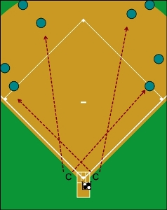
Equipment Needed
- 2 coaches on either side of home plate
- Either 2 players to receive thrown balls from the position players
- OR have position players roll balls off to side in a pile once fielded and ‘shaped to throw to 1st/2nd.’

Round 1- Straight up Groundballs
Coach 3B Side – Hitting groundballs alternatively to SS & 1B
Coach 1B Side – Hitting groundballs alternatively to 3B & 2B

Tip: After hitting routine groundballs straight, you can vary the drill and hit balls to the positions left and right

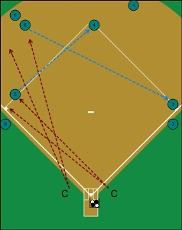
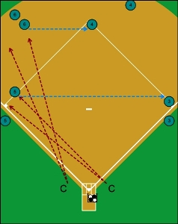
Round 2 – 5 – 3’s & 6 – 4’s
Coach 3B Side – Hitting groundballs to 3B who throws to 1B.
Coach 1B Side – Hitting groundballs to SS who throws/flips to 2B covering 2B.

Round 3 – 6-3’s & 5-4’s
Coach 3B Side- Hitting groundballs to SS who throws to 1B.
Coach 1B Side- Hitting groundballs to 3B who throws to 2B
Important – Make sure SS is playing “Back” when 3B is throwing across to 2B to keep them positioned away from throw.
Tip: Have 2B practice receiving the ball like they are going to turn a double play, however do not throw the ball.
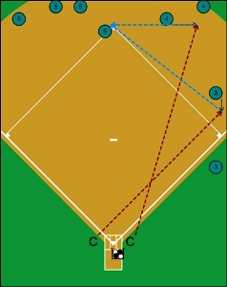
Round 4- 3-6’s (1B Play Back) & 4-6’s
Coach 3B Side- Hitting groundballs to 1B who throws to SS covering 2B.
Coach 1B Side- Hitting groundballs to 2B who throws to SS covering 2B.
Tip 1: Have 3rd baseman shift to SS/go to secondary position to join in on drill.
Tip 2: Have 1B alternate holding runners on or playing off the base.

